DMC Experience | 1.Must be trading as a company in the Republic of Azerbaijan for a minimum of two years
Application Requirements | DMC must operate with business meeting industry (incentive, corporate or conference) for the last two years  1.Two international client references relating to any of the above mentioned programs.  2.Two supplier references relating to any of the above mentioned programs.  The references must be returned to the Azerbaijan Tourism Board for review.
Services | Must have a MICE department within the organization.  Attendance of MICE Business Tourism overseas promotions (MICE Trade, shows/networking events/workshops over the last year.
Legislation | Full compliance with all relevant legislation
Tax | Company to be registered for VAT and a copy of Tax Clearance Certificate to be provided to Azerbaijan Tourism Board.
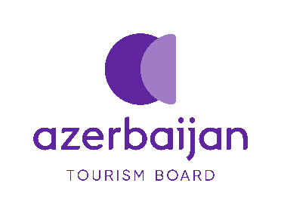
Destination Management Company Criteria

